From: https://medium.com/@caityjohnstone/trump-isnt-another-hitler-he-s-another-obama-51ea7db498b4

Caitlin Johnstone
Rogue journalist, poet, and utopia prepper.
Jan 5

Trump Isn’t Another Hitler. He’s Another Obama.
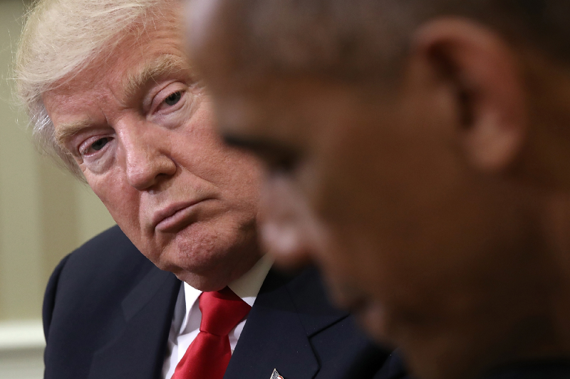
Not a lot of people remember this, but George W Bush actually campaigned in 2000 against the interventionist foreign policy that the United States had been increasingly espousing. Far from advocating the full-scale regime change ground invasions that his administration is now infamous for, Bush frequently used the word “humble” when discussing the type of foreign policy he favored, condemning nation-building, an over-extended military, and the notion that America should be the world’s police force.
Eight years later, after hundreds of thousands of human lives had been snuffed out in Iraq and Afghanistan and an entire region horrifically destabilized, Obama campaigned against Bush’s interventionist foreign policy, edging out Hillary Clinton in the Democratic primaries partly because she had supported the Iraq invasion while he had condemned it. The Democrats, decrying the warmongering tendencies of the Republicans, elected a President of the United States who would see Bush’s Afghanistan and Iraq and raise him Libya, Syria, Yemen, Pakistan, and Somalia, along with a tenfold increase in drone strikes. Libya collapsed into a failed state where a slave trade now runs rampant, and half a million people died in the Syrian war that Obama and US allies exponentially escalated.
Eight years later, a reality TV star and WWE Hall-of-Famer was elected President of the United States by the other half of the crowd who was sick to death of those warmongering Democrats. Trump campaigned on a non-interventionist foreign policy, saying America should fight terrorists but not enter into regime change wars with other governments. He thrashed his primary opponents as the only one willing to unequivocally condemn Bush and his actions, then won the general election partly by attacking the interventionist foreign policy of his predecessor and his opponent, and criticizing Hillary Clinton’s hawkish no-fly zone agenda in Syria.
Now he’s approved the selling of arms to Ukraine to use against Russia, a dangerously hawkish move that even Obama refused to make for fear of increasing tensions with Moscow. His administration has escalated troop presence in Afghanistan and made it abundantly clear that the Pentagon has no intention of leaving Syria anytime soon despite the absence of any reasonable justification for US presence there. The CIA had ratcheted up operations in Iran months into Trump’s presidency, shortly before the administration began running the exact same script against that country that the Obama administration ran on Libya, Syria and Ukraine.
Maybe US presidents are limited to eight years because that’s how long it takes the public to forget everything.

In the lead-up to the November elections those of us on the left who backed third parties were promised over and over and over again by Democratic party loyalists that if Hillary Clinton failed to secure the election there’d be goose-stepping stormtroopers patrolling the streets and murdering non-whites with impunity, concentration camps for Muslims and white supremacist extermination programs. Comparisons to Hitler went on nonstop, and anyone who failed to fall in line with the mainstream liberal narrative can attest that they were accused of aiding actual, literal Nazism on a regular basis.
A year into Trump’s presidency, and not only did the apocalyptic predictions of national genocide fail to come true, he’s not even deporting as many immigrants as Obama. He is, however, out-bombing him.
We were promised another Hitler. Instead, we got another Obama, who was himself another Bush. The march into corporatist Orwellian police state at home and globalist oligarchic hegemony abroad continues unhindered for the United States of America.
And of course that march would have continued had Hillary won as well, it just would have looked a bit different. Fewer environmental deregulations, likely catastrophic escalations against the Syrian government and possibly Russia, the exact same approaches to Iran, just as much hawkishness toward North Korea but minus the tweets about button sizes, no attempts at dismantling Obama’s corporatist healthcare plan. Not much more than that.
Nobody wants to hear this. The Democrats still want to believe that the sitting president is simultaneously a Nazi, a Kremlin secret agent, an idiot, and a lunatic, and Trump supporters want to believe that he’s a populist savior fighting to liberate the nation from the claws of the deep state. Because of their partisan blinders they will both find reasons to believe they’ve got either a savior or a traitor in the White House despite the fact that their country’s actual policy and behavior remains more or less the same.
I still sometimes get Democrats telling me that Trump is about to flip into Hitler 2.0 any minute now and start throwing non-whites into extermination camps. Whenever I point out that they were wrong about their “your choices are Hillary or Hitler” alarmism I get a bunch of them telling me “give him time”. Well he’s had time. They were wrong. They didn’t get a Nazi, they got another shitty neocon. And since the Dems have been paced into alignment with the neocons there’s no one left to oppose their agendas, which is why we’re seeing so little pushback on Trump’s Iran saber rattling.
I get Trump supporters telling me that he’s fighting the deep state, but the only way you can believe that at this point is to redefine “deep state” to mean “Democrats and their supporters”, which would actually just be more partisan bickering, which is all we’re actually seeing at this point. The only people you see pushing the collusion narrative and working for impeachment at this point are Democrats and Never-Trumpers; now that Trump has proven himself a good, compliant little boy the intelligence community has been putting its energy into the anti-detente propaganda effort to manufacture support for its new cold war escalations instead.
The MAGA crowd tells me their guy has de-escalated the Syrian situation in an attempt to paint him as less pro-war than his predecessor, but that’s not even true either. Until US troops actually leave Syria, all this administration has done is kill a bunch of people (many of them civilians), occupy parts of a sovereign nation, and refuse to leave. Why are those troops still there when Syria and its allies are perfectly capable of handling any remaining traces of ISIS as they have been? No good reason, that’s for sure.
This is not the fault of the American people. The American people consistently vote against interventionist wars (as evidenced by the fact that winning presidential candidates have to campaign against them), and while they may be guilted by the tribe into flag-waving once the troops are there, they consistently say no to every request for consent for more empire-building wars. In my recent article about how the CNN/CIA narrative is running the same script for Iran as they did for Libya and Syria, most of the pushback I received was from good people who wanted to make sure I knew that they didn’t consent to military intervention, they were simply offering their support for the people of Iran.
Which is about as naive and sweet as a kid wanting to help the nice old man find his puppy. I understand you wanting to help find the puppy America, but for God’s sake please don’t get in that man’s van.
So the will of the American people has been heard loud and clear. They do not consent to more regime change wars and more military interventions. They do not want that.
Through the trickery of the mainstream media though, they are paced by fear-mongering and guilting into a reluctant, bargaining, “Well okay then…” consent which is quickly turned over into flag-waving enthusiasm because you have to support your troops, don’tchaknow? And I get that! Everyone knows a serviceman or woman; you don’t want to make them feel sad or like their life is being wasted. That’s such a tragedy! Who wants to make that conscious?
Let’s be clear, too: the troops are often from some of the finest of working and middle-class families across the States, families whose strong sense of morality about right and wrong led their young sons and daughters to make the courageous decision to enter the armed forces. These young men and women were born with the most exemplary of desires. They want to make the world a better place and they are willing to make the ultimate sacrifice to do so. People love these families and they love their children.
These young people really are our best new humans. They are so committed to the highest interest that they would put aside their self-interest to do so. Do you know how rare that quality is in a human? And these young people are being taken from us young, whether that be by death or by destroying their beautiful minds as they are warped by the war machine into thinking that evil is good. Taken and used to pump up the egos of a selfish few.
In a healthy culture, the highest interest would dictate the desires of these young men and women. Unfortunately, the “highest interest” which should be assessed by the will of the people, is not being heard. It is not being enacted. The will of the people has repeatedly said that it does not want to send these young people off to kill another country’s young people to shore up the share portfolios of a few cancerous beings. The will of the people consistently says no to that, but it has been corralled by a small group of bloodthirsty vampires, parasites who will happily lay any amount of young bodies to waste to win their tiny dick battles until they are finally satisfied with the amount of zeroes on their bank statements.
Spoiler alert: they never will be.
Americans talk about “seeing through the partisan bullshit” of US politics like it’s some kind of magical superpower, but it’s not. Both parties act in slightly different ways toward the exact same ends, working together like the jab-cross combination of a boxer to advance the same warmongering, corporatist oligarchic agendas, and there’s no reason to believe any of them about anything. America has two corporatist war parties who serve a plutocratic class of elites; one of them wears a cowboy hat, the other has pink hair. That’s it. That’s all you need to see to free yourself from the illusion.
Please stop attacking one another for the evils that have been inflicted on you by this small group of sociopaths, America. Stop buying into the two-party good cop/bad cop schtick that the elites use to turn urban Americans against rural Americans and turn your anger toward your real enemies.
____________
Thanks for reading! My work here is entirely reader-funded so if you enjoyed this piece please consider sharing it around, liking me on Facebook, following me on Twitter, bookmarking my website, throwing some money into my hat on Patreonor Paypal, or buying my new book Woke: A Field Guide for Utopia Preppers.

Bitcoin donations:1Ac7PCQXoQoLA9Sh8fhAgiU3PHA2EX5Zm2
- Donald Trump
- Barack Obama
- Politics
- Government
- President
One clap, two clap, three clap, forty?
By clapping more or less, you can signal to us which stories really stand out.
13,189
133
• Following

Caitlin Johnstone
Rogue journalist, poet, and utopia prepper.

